EXPERIMENT 5: K-MEANS CLUSTERING
AIM:
To implement the K-Means clustering algorithm to group students based on their study hours and marks.
ALGORITHM:
- Import Pandas, Matplotlib, and KMeans.
- Load the dataset from data.csv.
- Select Hours_Studied and Marks as features.
- Create a K-Means model with three clusters.
- Fit the model to the selected features.
- Obtain the cluster labels for each data point.
- Add the cluster labels as a new column in the dataset.
- Display the clustered dataset.
- Plot the data points using different colors for the clusters.
- Display the cluster centroids on the graph.

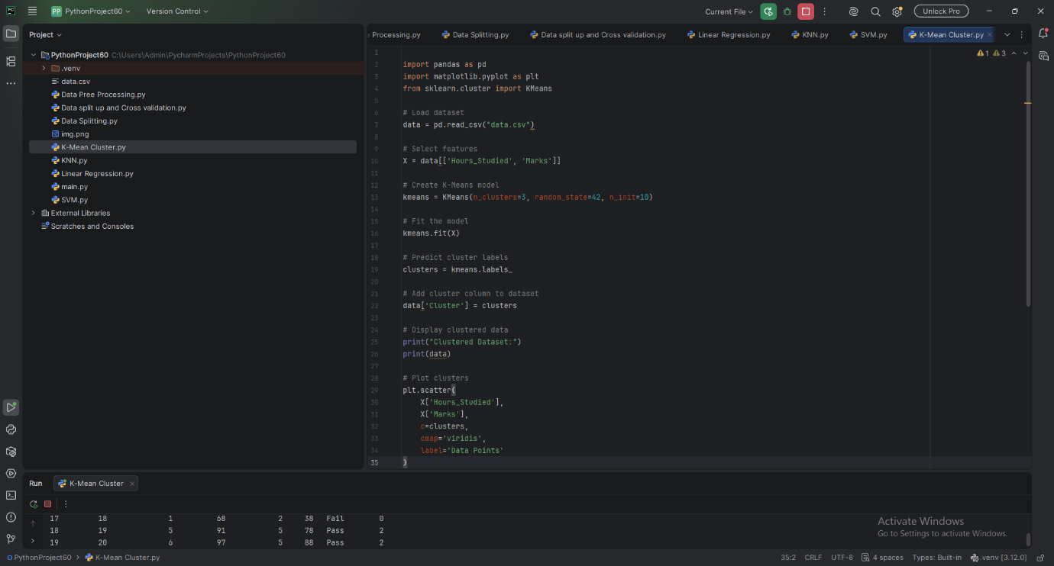
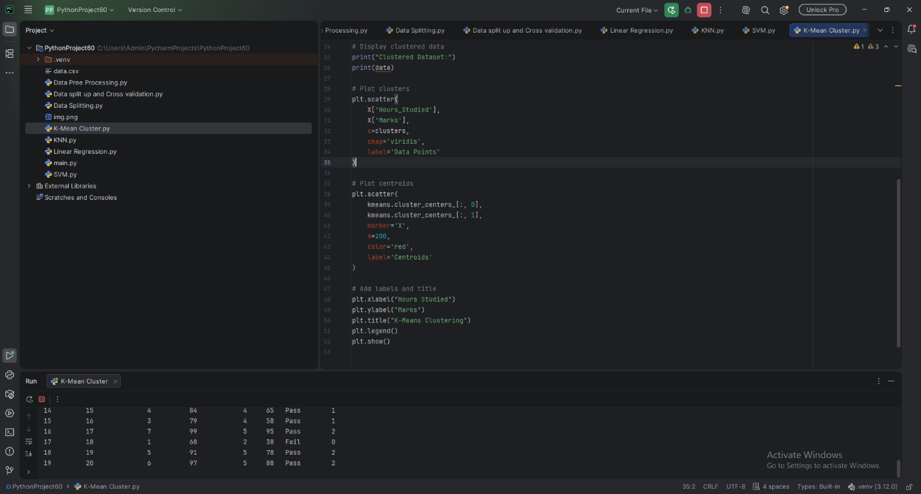

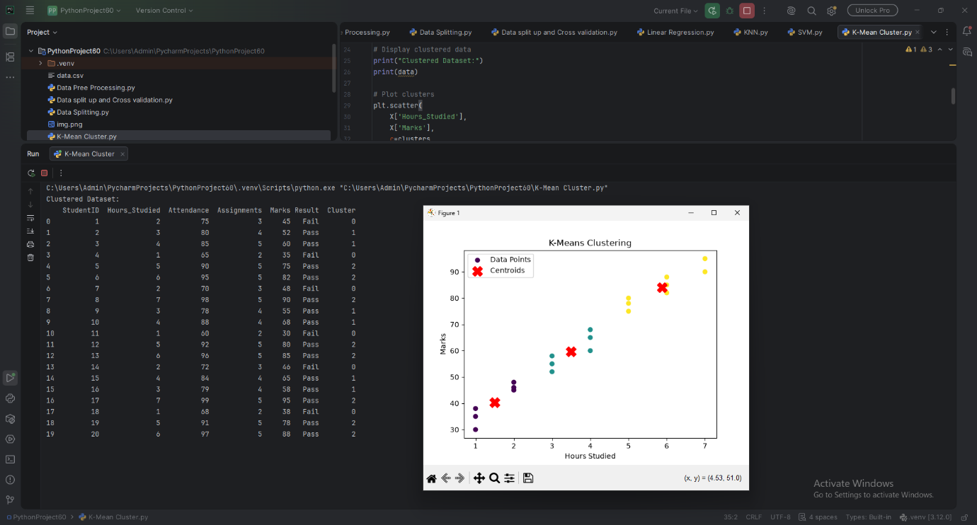

RESULT:
The K-Means clustering algorithm successfully grouped students into three clusters based on study hours and marks. The cluster assignments and centroids were displayed graphically.

